**23.36 Step 36**

To test that this line is accurate, unmount the /dev/sdb5 filesystem and remount it again by specifying only the mount point:

umount /data

root@ubuntu:~# umount /data

mount /data

mount

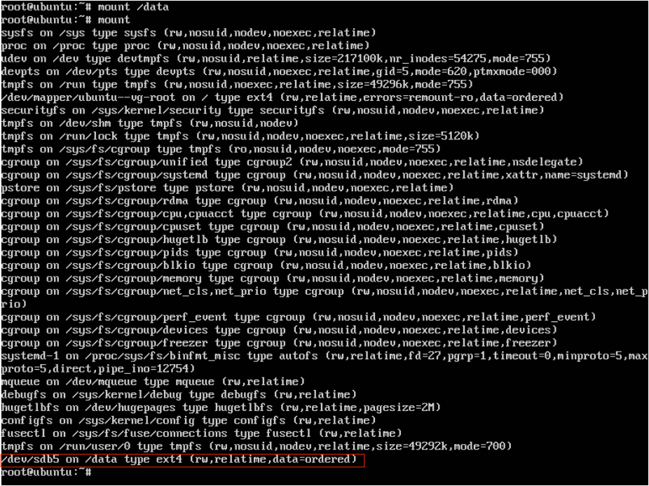

Recall that when you specify only the mount point, the mount command looks at the corresponding entry in the /etc/fstab file to determine the rest of the information needed to mount. If the mount command is successful, the entry in the /etc/fstab file is correct.

•